**Fibonacci Series**

**Aim :**

Write a Program to Generate Fibonacci Series using 8051 Microcontroller.

**Requirements :**

Keil uVision5 Software.

**Theory :**

**Fibonacci Series**

In Mathematics, the Fibonacci numbers, commonly denoted ***Fn,*** form a sequence, called the Fibonacci series, such that each number is the sum of the two preceding ones, starting from ***0*** *and* ***1.*** That is,

***F0 = 0, F1 = 1,*** *and* ***Fn = Fn – 1 + Fn – 2,*** *for* ***n > 1.***

The beginning of the series is thus :

***0, 1, 1, 2, 3, 5, 8, 13, 21, 34, 55, …***



Fibonacci numbers are named after Italian mathematician **Leonardo** of Pisa, later known as **Fibonacci.** In his 1202 book Liber Abaci, Fibonacci introduced the sequence to Western European mathematics, although the sequence had been described earlier in Indian mathematics, as early as 200 BC in work by Pingala on enumerating possible patterns of Sanskrit poetry formed from syllables of two lengths.

Fibonacci numbers appear unexpectedly often in mathematics, so much so that there is an entire journal dedicated to their study, the Fibonacci Quarterly. Applications of Fibonacci numbers include computer algorithms such as the Fibonacci search technique and the Fibonacci heap data structure, and graphs called Fibonacci cubes used for interconnecting parallel and distributed systems.

They also appear in biological settings, such as branching in trees, the arrangement of leaves on a stem, the fruit sprouts of a pineapple, the flowering of an artichoke, an uncurling fern, and the arrangement of a pine cone's bracts.

**Procedure :**

1. Open Keil uVision5 software. Click on **project** and select **new uVision project.**
2. Save the project in ASM folder of software directory. A popup window will come up in which we have to **select the device for target,** search **Intel** and select **8051AH** chip and press **ok.**
3. A popup window will come up with message **copy STARTUP.A51 to project folder?** Press **no.**
4. Now click on **new file,** write the program in this file and save it with **.asm extension.**
5. Now on the LHS **Project Window** expand **Target 1** and right click on **Source Group 1** and select **add existing file to group** and select your **.asm** file and click **Add.**
6. Press **F7** to **build target,** check for errors and fix them.
7. Now click on **Start/Stop Debug Session** and press **F5** to start code execution.
8. All the registers and flags are on the upper LHS, code on the upper RHS, command window on lower LHS and memory window on lower RHS.
9. To check the result in memory type **I:0x40** and press enter to observe the Fibonacci series.

**Program to Generate Fibonacci Series :**

|  |  |  |  |
| --- | --- | --- | --- |
| **Address** | **Mnemonics** | **Operands** | **Comments** |
| 0000H | ORG | 0000H | Start from Memory Location 0000H |
| 0000H | LJMP MAIN |  | Transfer program execution to MAIN(0040H) |
| 0000H | ORG | 40H | Start from Memory Location 40H |
| 0040H | MAIN **|** MOV R0 | #40H | Memory Location of Series |
| 0042H | MOV R3 | #08 | Number of Elements in the Series |
| 0044H | MOV R1 | #00H | Move 00H Data to R1 Register |
| 0046H | MOV @R0 | #00H | Move the 1st Number in Memory |
| 0048H | INC R0 |  | Increment R0 Register |
| 0049H | MOV @R0 | #01H | Move the 2nd Number in Memory |
| 004BH | MOV R2 | #01H | Move 01H Data to R2 Register |
| 004DH | LABEL2 **|** INC R0 |  | Increment R0 Register |
| 004EH | MOV A , R1 |  | Move the Contents of R1 to A |
| 004FH | ADD A , R2 |  | Add the Previous Two Numbers |
| 0050H | MOV @R0 , A |  | Store the Result of Addition in Memory |
| 0051H | MOV B , R2 |  | Move the Contents of R2 to B |
| 0053H | MOV R1 , B |  | Move the Contents of B to R1 |
| 0055H | MOV R2 , A |  | Move the Contents of A to R2 |
| 0056H | DJNZ R3 , LABEL2 |  | Jump to LABEL2 if R3 ≠ 0 |
| 0058H | END |  | End of program |

**Screen Shots :**

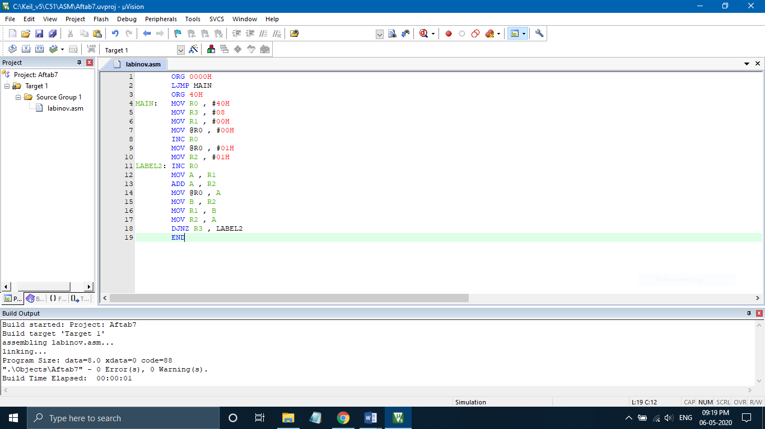

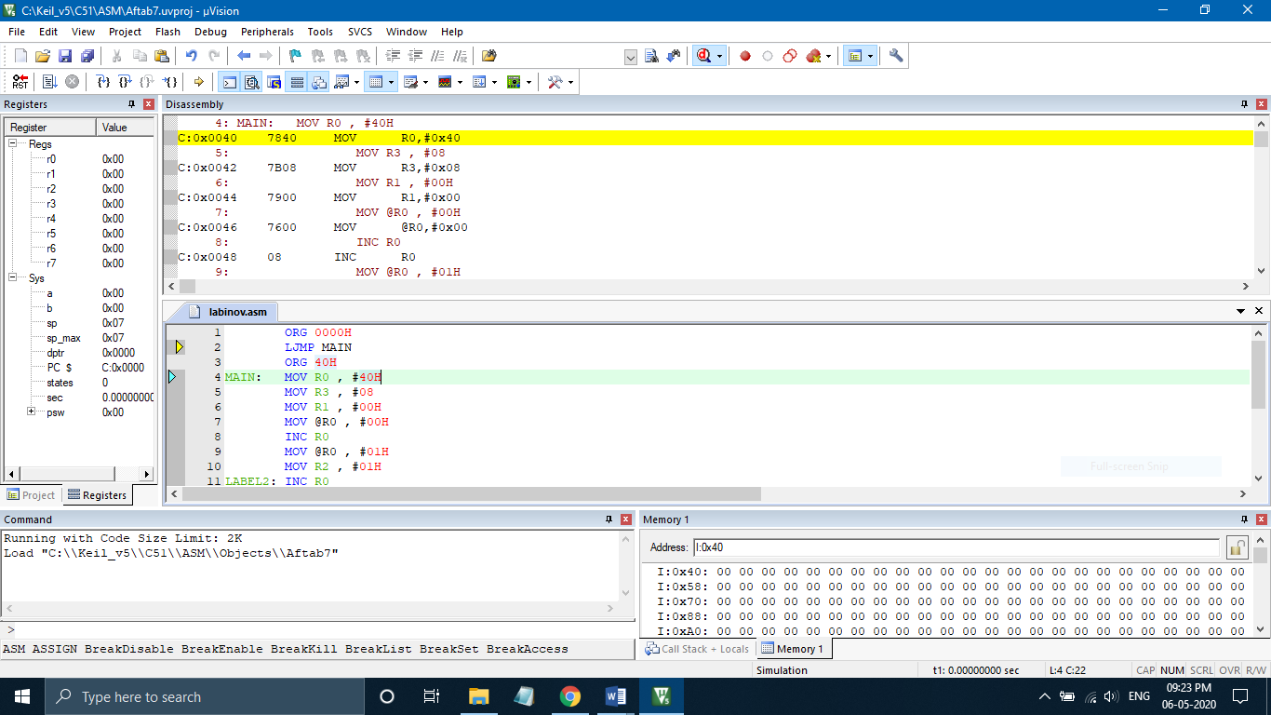

**Flow Chart :**

**No**

**Yes**

**Output :**

|  |  |
| --- | --- |
| **Before Execution** | **After Execution** |
| |  | | --- | | **R3 (Counter)** | | **08H** |  |  | | --- | | **R1 (Previous Number)** | | **00H** |  |  | | --- | | **R2 (Current Number)** | | **01H** | | |  |  | | --- | --- | | **0040H** | **00H** | | **0041H** | **01H** | | **0042H** | **01H** | | **0043H** | **02H** | | **0044H** | **03H** | | **0045H** | **05H** | | **0046H** | **08H** | | **0047H** | **0DH** | |

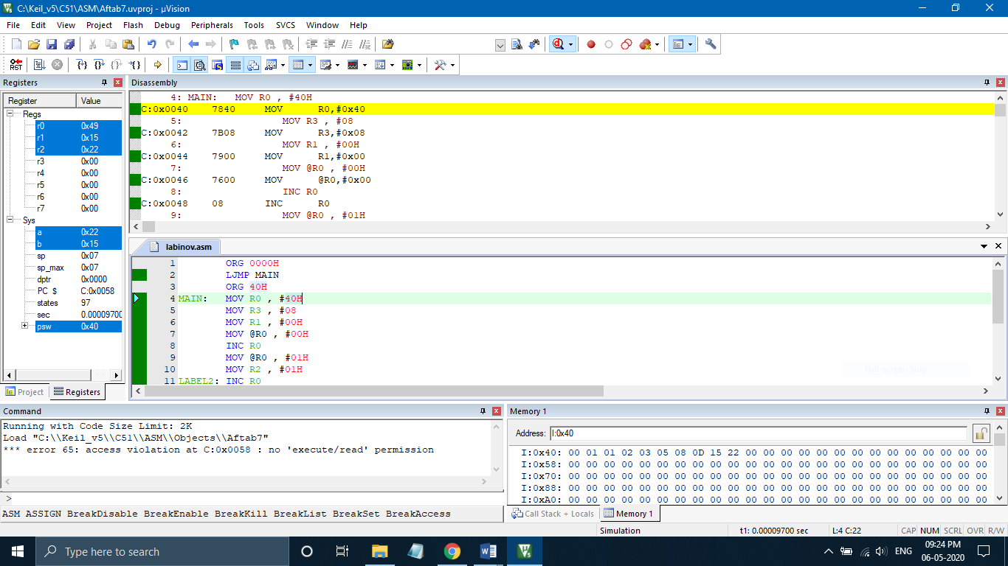

**Result :** Program to Generate Fibonacci Series using 8051 Microcontroller was implemented successfully.